SSR Executive Travel LTD (MK)

15 Orne Gardens, Bolbeck Park, Milton Keynes,
MK15 8PG
Telephone: (01908) 38 26 46
Email: info@ssrexecutivemk.com
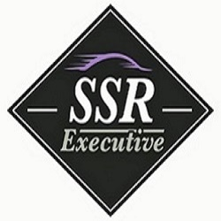
COMPANY ACCOUNT APPLICATION FORM

Company Name:

Registered number:
(OR Please state if sole trader)

Registered Address:

Main account contact:

Position of contact:

Telephone number:

Accounts Contact:

Telephone number:

Email Address (for invoice/statements):

I/we confirm that I/we agree to SSR Executive Travel Ltd performing a credit check with Equifax PLC for the sole purpose of opening a credit account with SSR Executive Travel Ltd
Please sign and send back to info@ssrexecutivemk.com

Signed _________________________ Name in Capitals _______________________

Date: _________________________

